Assessment Screenshots

Davishankar Gaur

1. Home page should give a welcome message.

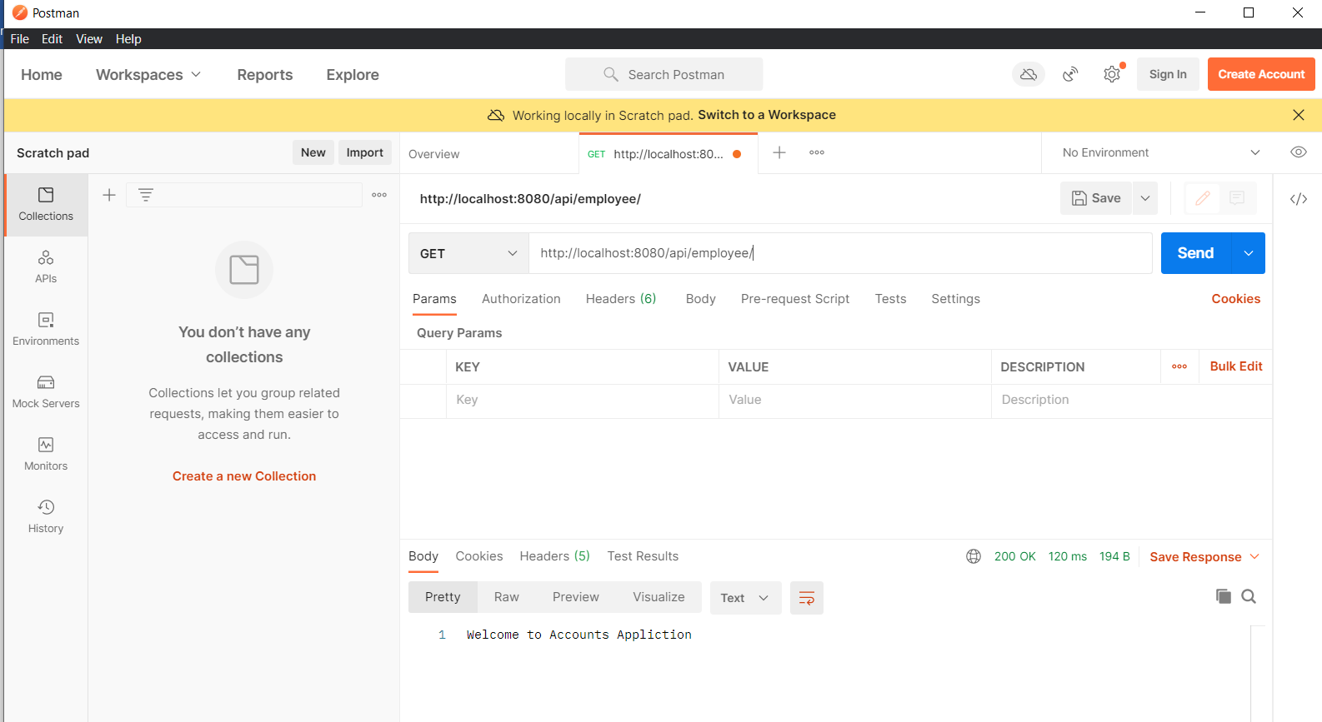

1. POST method – Create account resource

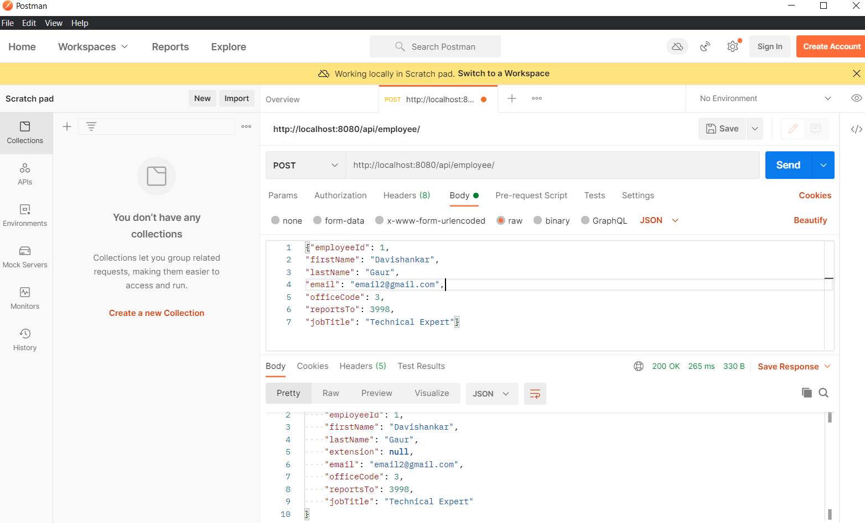

1. GET method – Read account resource

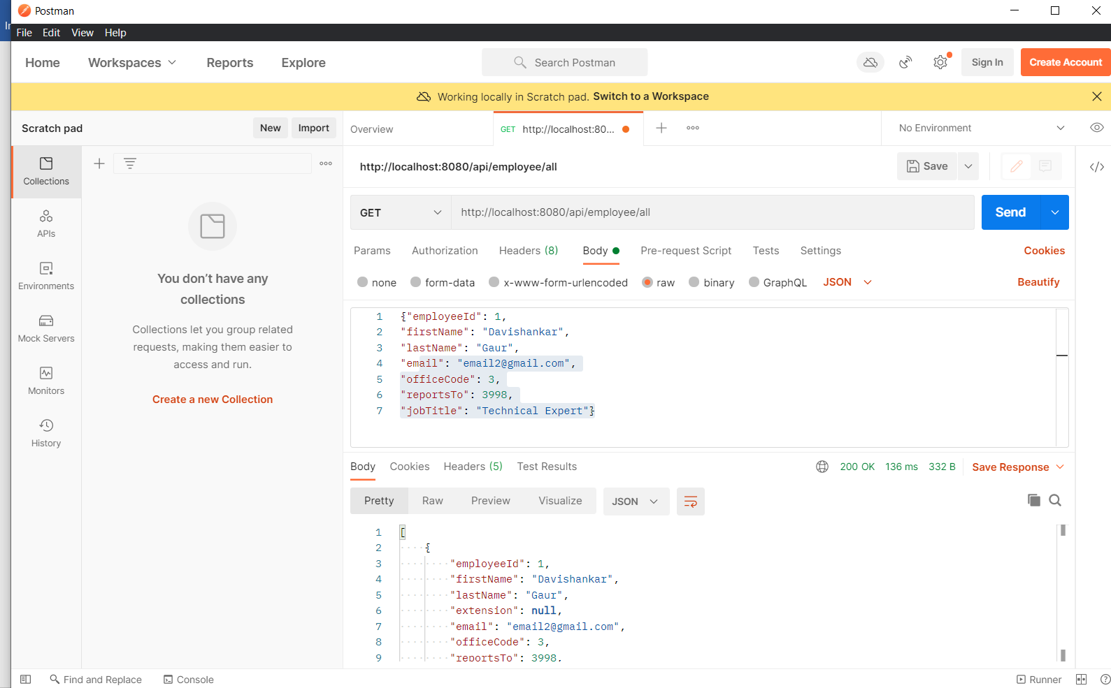

4)PUT method – update the account resource

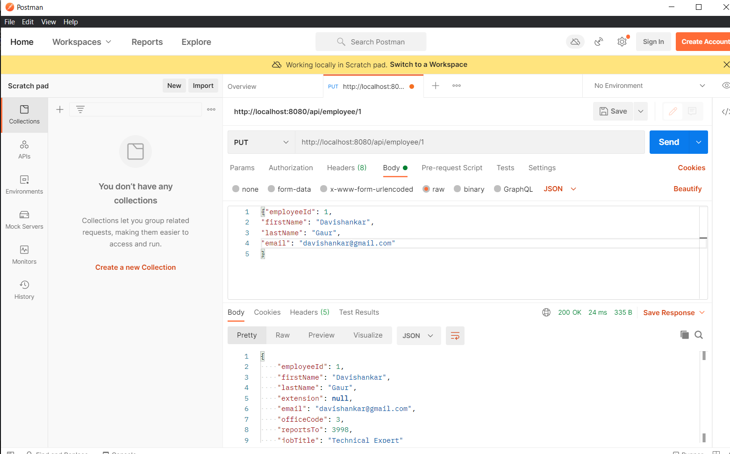

5) DELETE method- delete account resource

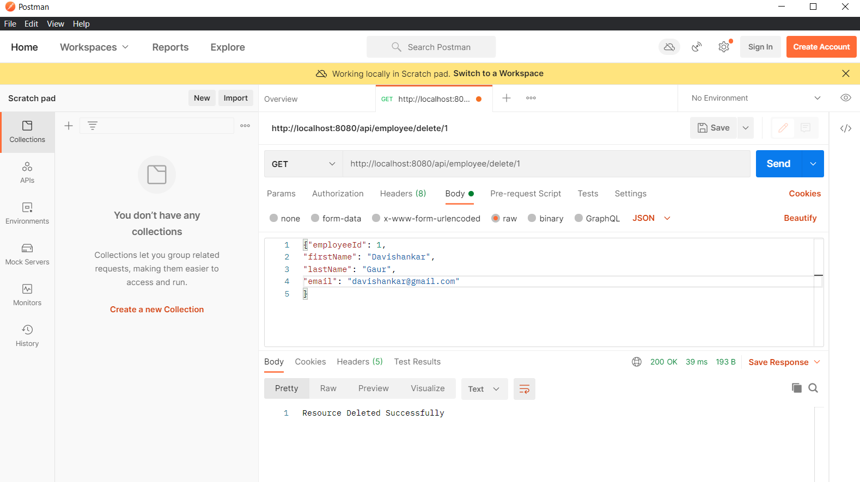

6) READ all account resources using GET http method.

